
ACTIVATION PLAN
Diamitani Industries
×
Praecipio Consulting

September 9, 2026 · 4:59 PM CT
Written by Patrick Diamitani
PREPARED EXCLUSIVELY FOR PRAECIPIO CONSULTING · CONFIDENTIAL

01 Overview
About the Engagement
Praecipio Consulting is currently reviewing Patrick Diamitani for an internal GTM role, or for a Forward Deployed AI Engineer opportunity.
This plan proposes an alternative: a six-month consulting activation, with the option to renew, in which Patrick consults, strategizes, and executes on a range of internal go-to-market efforts for Praecipio Consulting — without the overhead of a full-time hire, and with a scope built specifically around Praecipio's tools, team, and pipeline.
02 Scope of Engagement
Core Deliverables
Six systems form the core of this engagement. Each combines a piece of Praecipio's existing stack with a purpose-built AI workflow.
- Prospect Automation Workflow — Combine Praecipio's technical stack with its Ideal Customer Profiles to build a system that generates leads, conducts research, and sends personalized outbound messages on behalf of sales reps.
- Inbound Automation Workflow — Combine the CRM and the website's contact submission form with a system that classifies every inbound message, correctly assigns MQLs to the right internal team, and increases lead-to-response speed.
- Pre-Call Workflow — Combine upcoming external meetings with prospect research to automatically generate a briefing report and deliver it to the team member taking the call.
- Post-Call Workflow — Combine past meetings with call transcript research to analyze outcomes and automatically execute the appropriate follow-up message or task.
- Daily Execution Report — Combine daily runs across all active workflows into a system that sends a spreadsheet and summary of any failed automations.
- Go-To-Market Dashboard — Pull data from Praecipio's platforms and systems, combined with agreed-upon KPIs and metrics, into a single dashboard that visualizes GTM performance.
Ad Hoc Support
Beyond the six core systems, Patrick will construct and improve ad hoc workflows, skills, and agents as needed throughout the engagement — responding to whatever the GTM team's priorities require, month to month.
03 Optional Expansion Projects
Available as extensions to the core engagement, scoped and priced separately as priorities emerge:
- Custom SDR Agent — Connect Claude models to a chatbot interface, giving the team direct, conversational access to GTM activities: calling, lead generation, outreach, and research.
- Sales Enablement Agent — Connect and configure the broader tech stack into a single, optimized, AI-native system that gives every employee a consistent approach to their workflow.
- GTM Center of Excellence — Build a library of internal skills and workflows, paired with AI-generated tutorial and curriculum videos, to train the team on each tool.
04 Engagement Process
Phase 1 — Assessment
- Patrick and the Praecipio team conduct an initial assessment session
- Review existing tools, projects, plans, and KPIs
- Align on goals and next steps
- Transfer logins and credential access needed to begin work
Phase 2 — Roadmap
- Patrick constructs a personalized roadmap, covering:
- Scope of Work (SOW)
- Delivery timeline
- Expected outcomes and deliverables for each system
Phase 3 — Review
- Patrick and the team review the roadmap together — open thoughts, what's working, and constructive changes before build begins
Phase 4 — Terms
- Both sides confirm engagement terms:
- Timeline — when to expect delivery
- Transaction — when payment will be made
- Technology — which systems are in scope
Phase 5 — Execution
- Patrick begins the project
05 Timeline & Key Dates
Initial Engagement | September 28, 2026
Proposed Start Date | Monday, October 5, 2026
3-Month Check-In | Q1 2027 — weekly office hours, standups, and training sessions, with unlimited communication by text, email, and call throughout.
06 Relevant Systems
Selected Work
A sample of comparable systems already built and running in production — the same category of work proposed in this plan.
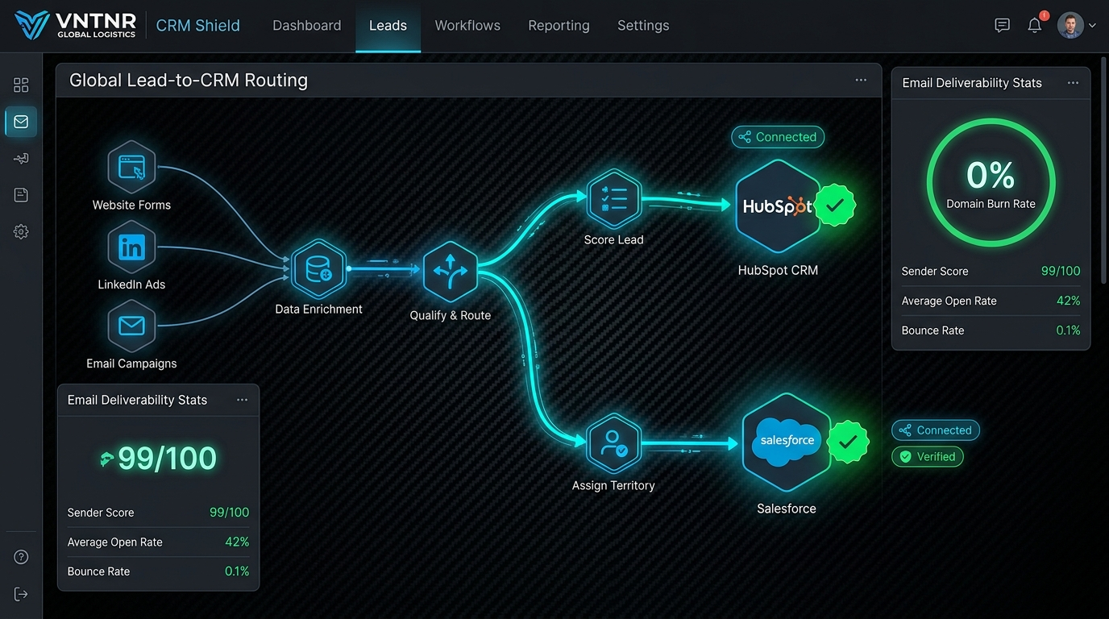
PROSPECT & INBOUND ROUTING
VNTNR Global Logistics — CRM Shield
Lead-to-CRM routing across HubSpot and Salesforce, with data enrichment, qualify-and-route logic, and live email deliverability monitoring — the same architecture proposed for Praecipio's inbound automation workflow.
Stack: HubSpot, Salesforce, data enrichment, real-time monitoring
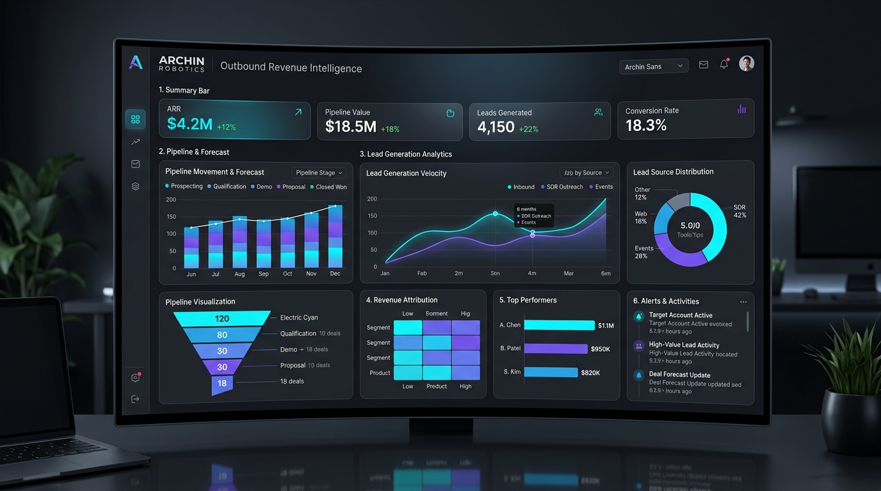
GTM DASHBOARD
Archin Robotics — Outbound Revenue Intelligence
A single-view GTM dashboard combining pipeline forecast, lead generation velocity, lead source distribution, revenue attribution, and top-performer tracking — the model for Praecipio's proposed GTM dashboard.
Stack: CRM data pull, KPI visualization, revenue attribution
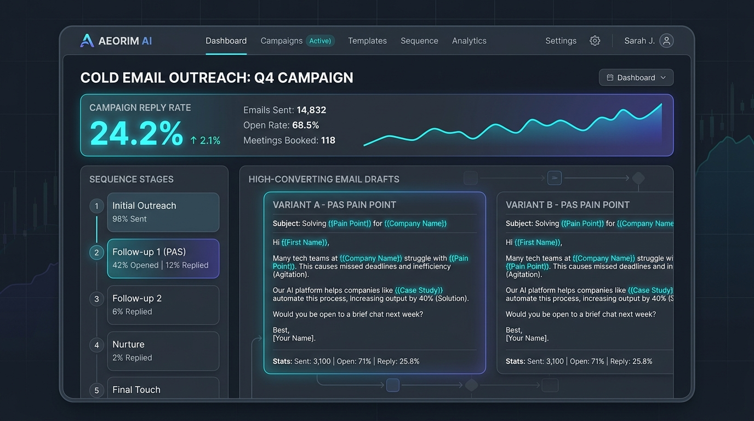
OUTBOUND AUTOMATION
Aeorim AI — Cold Email Outreach
A sequenced outbound system with tested message variants, live open- and reply-rate tracking, and staged follow-up logic — directly applicable to Praecipio's prospect automation and outbound ops.
Stack: Sequenced campaigns, A/B variant testing, analytics
07 Next Steps
If this structure works for Praecipio, the next step is the initial assessment session outlined above — reviewing tools, KPIs, and access, and setting the September 28 engagement date.
Happy to walk through any part of this plan live.
Patrick Diamitani
Founder & Principal, Diamitani Industries, Inc.
patrick@diamitani.com · diamitani.com

